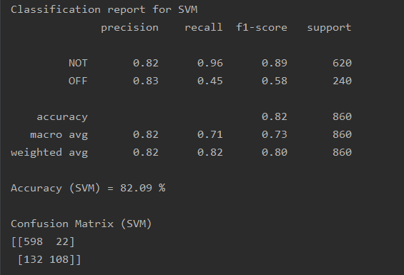

Classification report for SVM

precision recall f1-score support

NOT 0.82 0.96 0.89 620

OFF 0.83 0.45 0.58 240

accuracy 0.82 860

macro avg 0.82 0.71 0.73 860

weighted avg 0.82 0.82 0.80 860

Accuracy (SVM) = 82.09 %

Confusion Matrix (SVM)

[[598 22]

[132 108]]

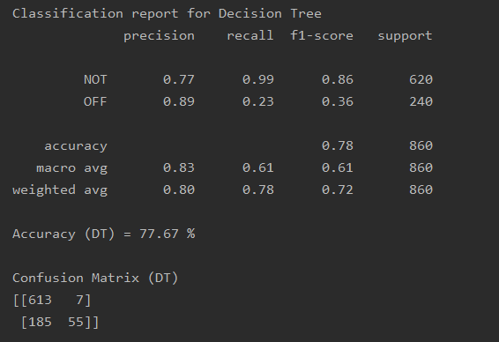

Classification report for Decision Tree

precision recall f1-score support

NOT 0.77 0.99 0.86 620

OFF 0.89 0.23 0.36 240

accuracy 0.78 860

macro avg 0.83 0.61 0.61 860

weighted avg 0.80 0.78 0.72 860

Accuracy (DT) = 77.67 %

Confusion Matrix (DT)

[[613 7]

[185 55]]

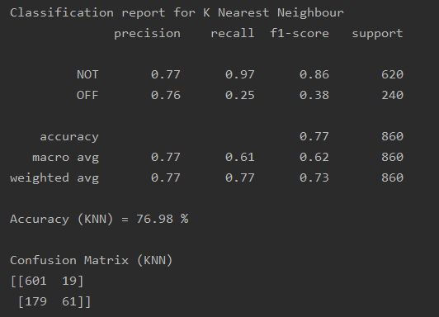

Classification report for K Nearest Neighbour

precision recall f1-score support

NOT 0.77 0.97 0.86 620

OFF 0.76 0.25 0.38 240

accuracy 0.77 860

macro avg 0.77 0.61 0.62 860

weighted avg 0.77 0.77 0.73 860

Accuracy (KNN) = 76.98 %

Confusion Matrix (KNN)

[[601 19]

[179 61]]

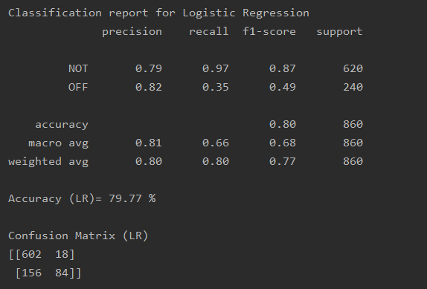

Classification report for Logistic Regression

precision recall f1-score support

NOT 0.79 0.97 0.87 620

OFF 0.82 0.35 0.49 240

accuracy 0.80 860

macro avg 0.81 0.66 0.68 860

weighted avg 0.80 0.80 0.77 860

Accuracy (LR)= 79.77 %

Confusion Matrix (LR)

[[602 18]

[156 84]]